4-H Online 2.0 Animal Entry Guide
Beef Projects (Breeding, Market and Dairy Cow)
*Note: For 4-H Members 8 and above

Log into 4-H Online

- You family email and password co.4honline.com

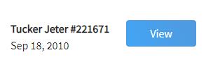
Click “View”, next to Member’s Name

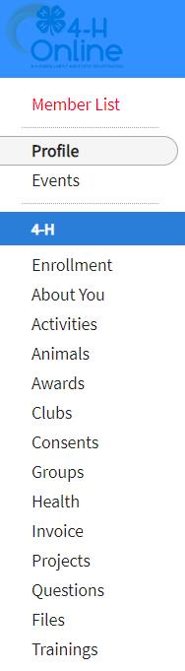
Locating ‘Animals’
- Desktop, select “Animals” from the left side navigation

- Smart Phone or Tablet, click on the 3 bars in the top left corner
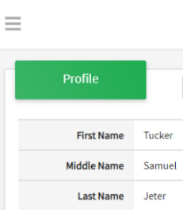
With either option, this will bring up a drop down list to begin adding Animals.

Adding an Animal
- Click "Add an Animal"
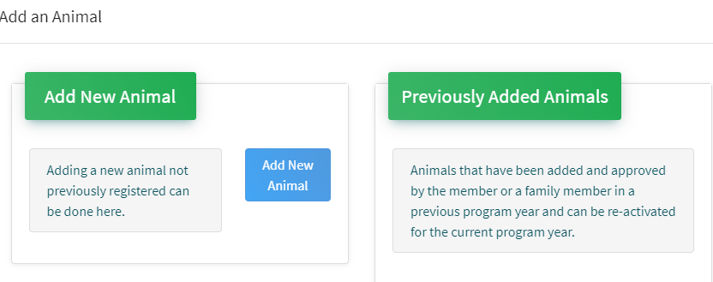Then select “Add New Animal”
- Select Beef Market, Beef Breeding or Dairy Cow, from the drop down.
REQUIRED: Enter Tag Number. NOTE: If animal does not have a county tag enter 000.
Click “Save”
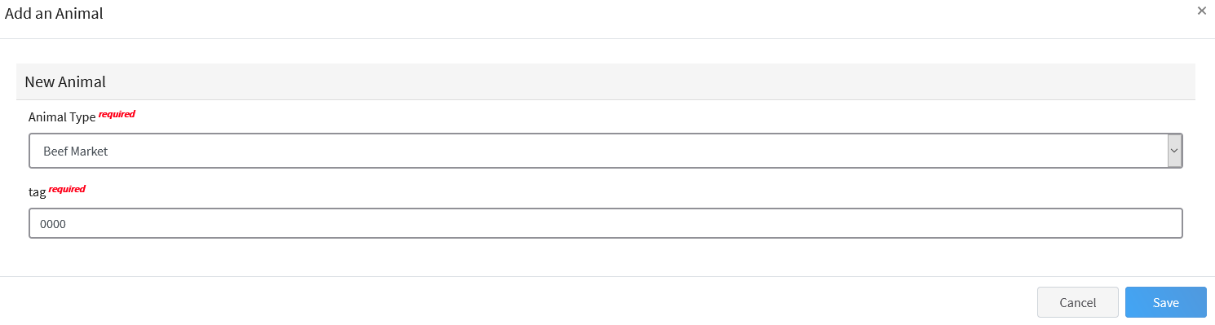

- Next, click “Show Questions” – NOTE: Check county requirements and complete accordingly.
Animal Entry is open for the current enrollment year. - Is all information complete? Check all county animal entry deadlines.
READ All County instructions for each animal species as county requirements vary.
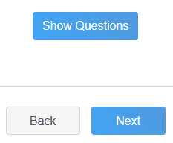
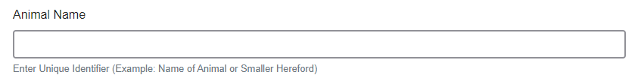
- Enter the animals name or other unique identifier, in the case of no tag number. This information will assist County Staff using the FairEntry or other system for County Fairs.

- Enter the beginning weight of the animal. If this Market Beef or Breeding Beef was weighed in at an official tag in/weigh in use that weight, otherwise use the weight of the animal at the time you purchased or if home-raised, when it was born.

- Choose the date of the beginning weight entered above

- Choose the breed from the drop down box. Choose *Other/Cross Breed or Mixed Breed. You can only choose one breed
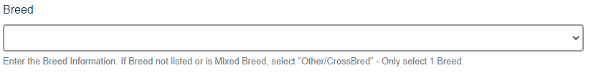

- Add Premises ID or Location ID, if applicable in your county.
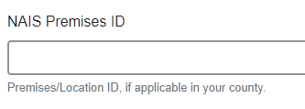
- Select the animal gender from the drop down box. Steers will need to be put under male.
- The tag number entered on the first screen will carry over to this screen. Please verify that they tag number is correct for the animal entered above.
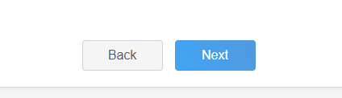
- Click “Next”, continue with the “File Uploads” that are required by your local county extension office. These will vary by county and species. Please follow your county guidelines.
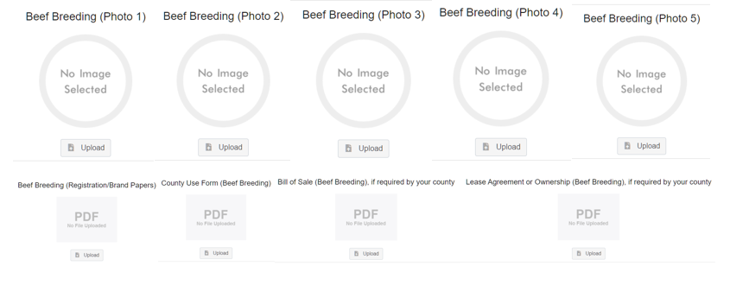

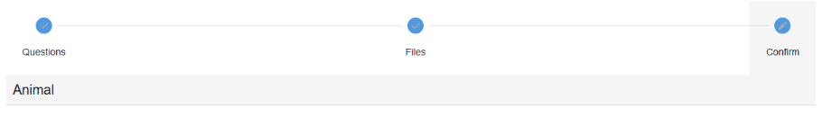
- Confirm all information, click ‘submit’
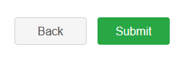
- County Extention staff, will review all information. If more is needed, members can edit. Once “Approved” by your local county extension office an email will be sent to your family account (example below) A time and date stamp for each animal.
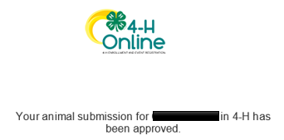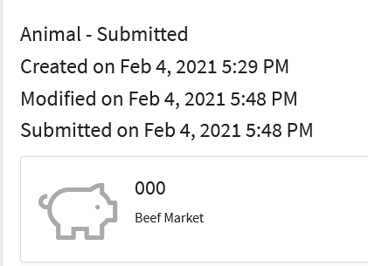
Questions, please contact your local extension staff.

